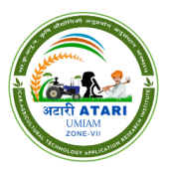    कृषि विज्ञान केंद्र, चुराचांदपुर, मणिपुर  ICAR - Krishi Vigyan Kendra, Churachandpur, Manipur  ICAR Research Complex for NEH Region, Manipur Centre | 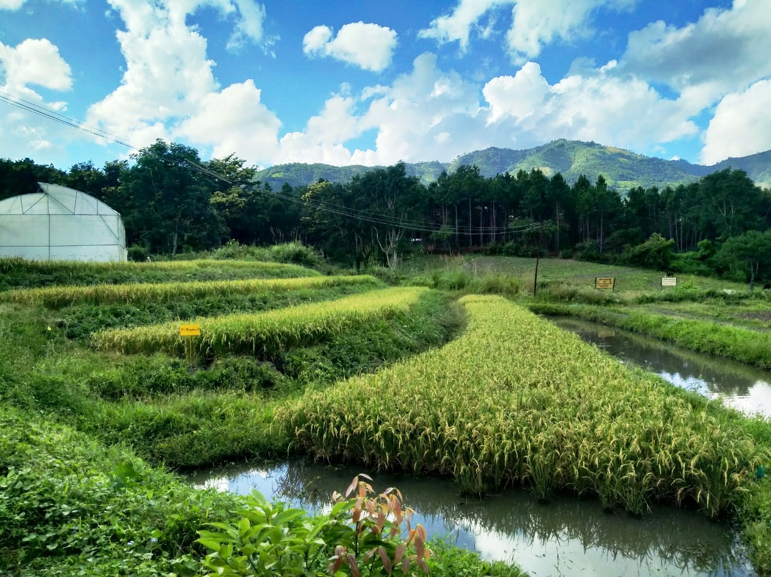 | 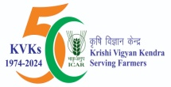  

A sample of the heading
Mandates of KVK
The overall mandate of the KVK is to develop and disseminate location specific technological modules at district level through Technology Assessment, Refinement and Demonstration and to act as Knowledge and Resource Centre for agriculture and its allied activities. The specific activities to carry out this mandate are:
- Conducting On-farm testing to identify the location specific agricultural technologies under sustainable land use farming systems
- Organizing frontline demonstrations to establish production potential on various enterprises at farmers’ fields
- Organizing need based training of farmers / farm women, rural youth and field level extension functionaries to update knowledge and skills in modern agricultural Creating awareness about improved technologies to larger masses through appropriate extension programmes
- Production quality planting materials, livestock, poultry and fisheries breeds and bio products
- Work as resource and knowledge centre of agricultural technology for supporting initiatives of public, private and voluntary sector for improving the agricultural economy of the district.
Services
- Extension and Advisory Services
- Interaction with the concern experts of Krishi Vigyan Kendra & get consultancy on issues related to agriculture & allied fields or information on advanced technological options.
- Krishi Vigyan Kendra arranges demonstrations & trials at farmers’ fields.
- Predicted Weather information services to the farmers for preparation of field activities such as pest and disease outbreak and to decide the water requirement of the crops.
- Diagnostic visits to their problematic fields for getting curative & diagnostic recommendations.
- Training to farmers, farm women, rural youths & extension personnel.
- Demonstrations of improved technologies.
- Farm Publications.

